Experiment 9 **LED TOGGLE USING 8051 USING KEIL AND PROTEUS**

**AIM:**

Write an assembly language program for LED Toggle Using 8051 using Keil and Proteus

**SOFTWARE REQUIRED:**

* Keil software 5.
* Proteus 8 software.

**KEIL PROCEDURE:**

1. Open the software, Click on project and open new version project.

2. Create a new project file

3. Enter AT89C51

4. Click NO

5. Click [Ctrl +N] and Type the code

6. Open project and click Build target

7. Open Build target and open source file and ADD, CLOSE

8. Click build target

9. Next debug start and stop

10. Open peripherals and select port 2

11. Now run the program in Debug

12. Open project and click optional properties and in that give output as hex file.

13. Create hex file.

**PROTEUS PROCEDURE:**

* Open proteus by clicking run as administrator.
* Open new project and enter the file name.
* Click next, next, next and finish.
* Click P symbol and search keyword and place the required components

The components required are:

* AT895C1
* LED-BARAGRAPH-RED
* CRYSTAL
* CAP
* GROUND TERMINAL
* As per declaration so do your connection

5. Connect pin number from 21 to 28 in led baragraphred

6. And then ground to led baragraphred pin you have to connect

7. Left the pin number 11 and 12 in led bargraph and expect this connect all pin to GND

8. U1 19 and 18 pin have to connect in crystal

9. Crystal line you have to connect in GND

10. And then touch the crystal component &change the crystal value and capacitor value

11. Crystal value=16mhz & capacitor value=33pF

12. Give input to AT89C51 as HEX file.

14. Start the simulation process

**PROGRAM:**

ORG 0000H

UP: MOV P2,#55H

ACALL DELAY

MOV P2,#0AAH

ACALL DELAY

SJMP UP

DELAY:MOV R4,#10

H1:MOV R3,#255

H2:DJNZ R3,H2

DJNZ R4,H1

RET

END

**CIRCUIT DIAGRAM:**

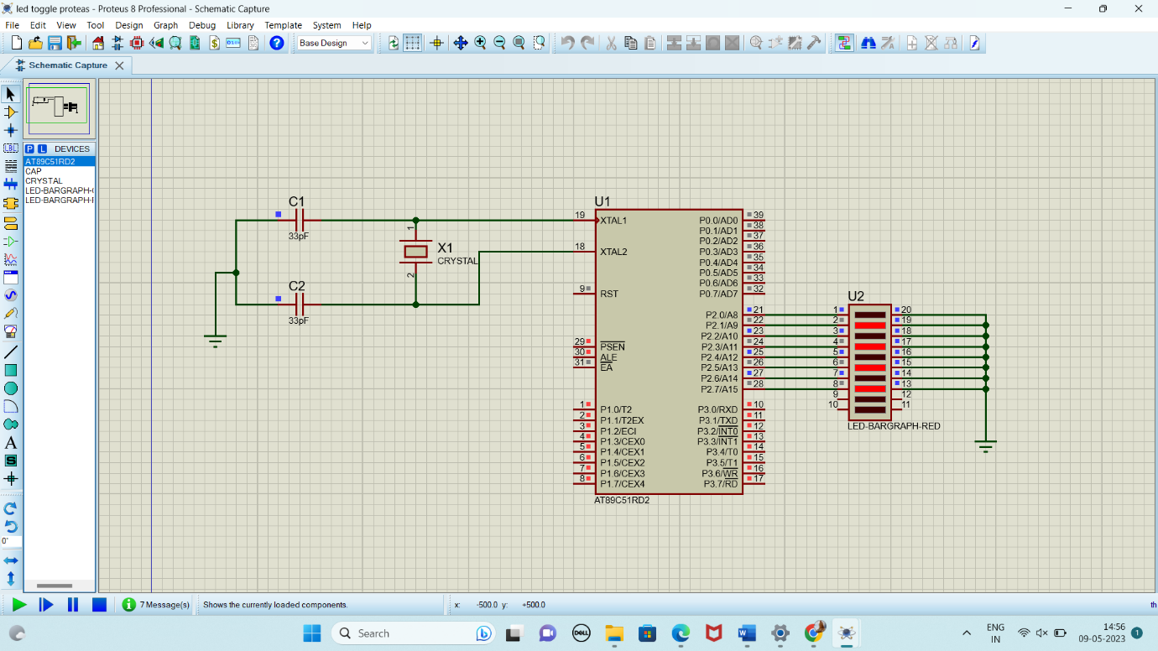

**RESULT:**

Thus the program has been successfully verified and executed.